W205 summer 2017 section 2 – Lab05 - K Iwasaki

***Question 1: What is the output of \dt?***

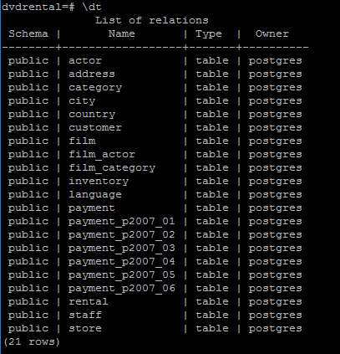

***Question 2: What is the schema for the customer table?***

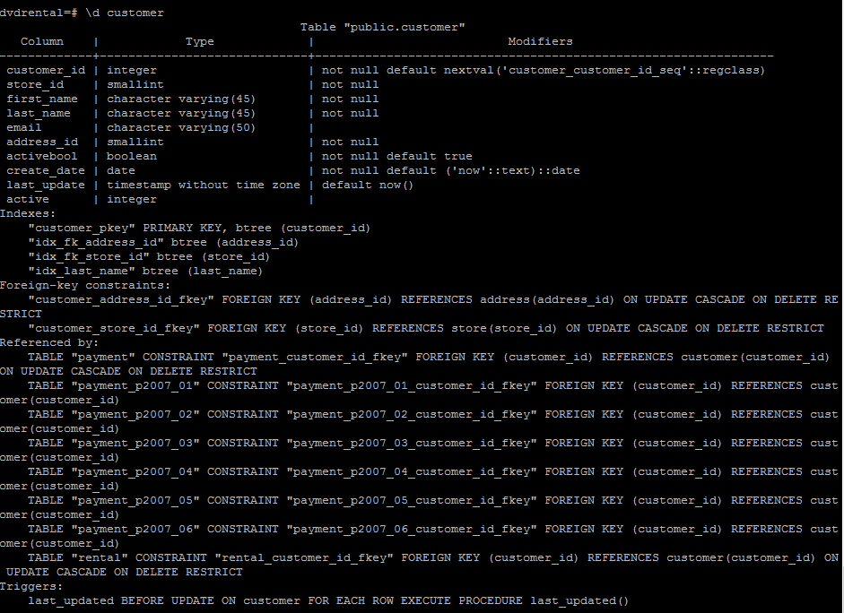

***Question 3: What similarities do you see in the explain plains for these 3 queries?***

All of them use “seq scan” on a chosen table for each case. Two of them use “Append” and “Filter” to filter and append data that match conditions.

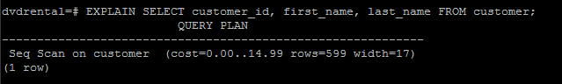

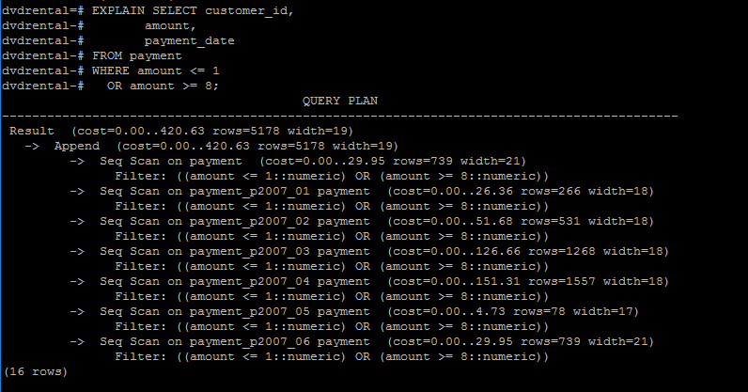

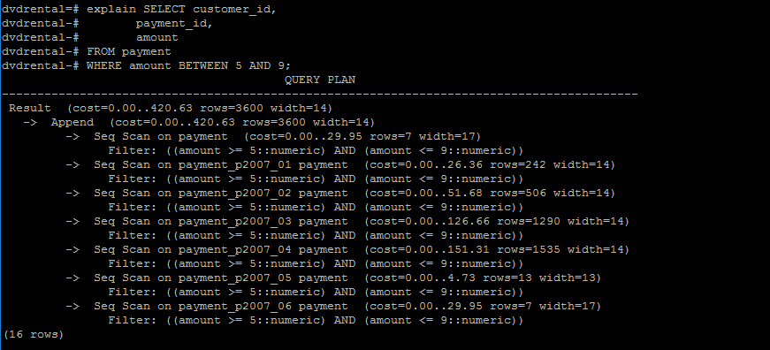

***Question 4: What is the difference between the plans for the Partitioned table and the union query? Why do you think this difference exists?***

The biggest difference is that union query plan includes HashAggregate two times while partitioned table query includes HashAggregate only one time. This is probability because for union query applies HashAggregate to each table and then applies HashAggregate to combined table. This makes union query much more expensive than portioned table.

Union of 2 tables

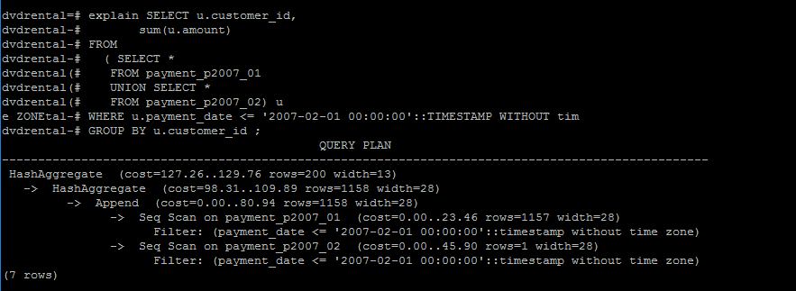

Partitioned Table

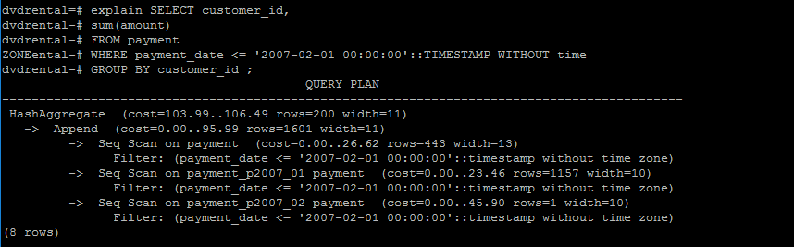

***Question 5: What join algorithm is used for the inner join?***

Hash Join

